Policy
Quality Policy

Description

Hunter Home Modifications has guidelines for all employees regarding our Quality Policy.

Purpose & Scope

The purpose of this policy is to explain the general procedures relating to the Quality Policy.

The following guidelines are to be adhered to by all managers, supervisors and employees.

Policy & Procedure

Hunter Home Modifications is engaged in the business of providing Home Modifications and Maintenance along with Occupational Therapy Assessments and this policy applies to all of our divisions throughout the organisation.

The purpose of this policy is to confirm our commitment to meeting the quality standards expected by our customers in the delivery of the products and/or services that we supply to them.

Our quality system is based on the requirements of ISO 9001 and is used as a tool to Use the Quality Management System as a tool in achieving best practice outcomes across the organisation and to ensure continuous improvement.

Our quality objectives are to:
- Compliance with all regualtory and statutory requirements
- Obtain client satisfaction rates > 90% over 2018
- Quality of product - Reduce production non-conformances < 5% of total production
- Quality of service provision ≥ 95%

To implement this policy we shall focus on the needs of our business with particular reference to consistently meeting our customers' requirements and statutory obligations. Our quality management system will provide mechanisms for detecting system shortfalls and for stimulating process improvements.

Hunter Home Modifications will adopt procedures and disciplines to ensure that:
- The system is effectively implemented by undertaking relevant skills training and conducting appropriate quality awareness training;
- Responsibilities for quality are established by communicating these responsibilities clearly to all employees;
- The policy and procedures continue to be appropriate by initiating regular reviews to check its effectiveness and ongoing relevance, and the company regularly review the needs and expectations of our customers and initiate continuous improvement activities to meet these expectations.

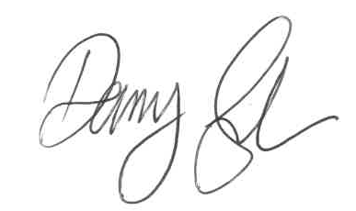

Chief Executive Officer

Date: 01/02/2018

This document is under version control.
Version | 2.2 | Created Date | 22 Nov 2016
Created By | Danny Gibson | Modified Date | 01/02/2018
Modified By | Andrew Mitchell | Status | Current
Tag |  | Approved By | CEO

